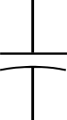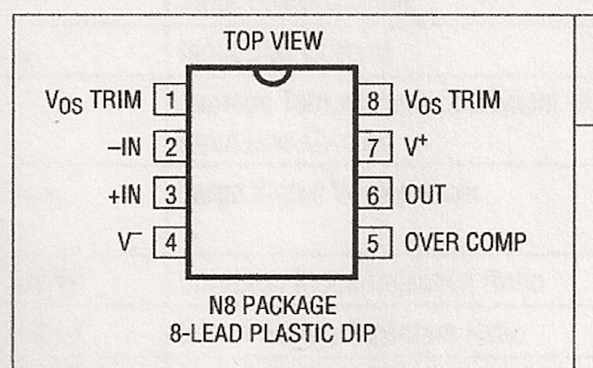
1
3
+
2
-
6
8
LT1097CN8
5
Over comp
7
4
V-
Thermistor
P1 - 10KΩ
R2 - 1MΩ
R1 - 27Ώ
5V
0V
- +
ST60R
Thermopile detector
C1 - 0,1µF
J1
J2

